**NOBUY.COM(Online Rental Site)**

Submitted in partial fulfillment of the requirement for the

degree of BCA

**BACHELOR OF COMPUTER APPLICATION**

**[2021-2022]**

**TO THE**

**ST.JOSEPH’S EVENING COLLEGE**

**(AUTONOMOUS & RE-ACCREDITED BY NAAC)**

**Museum Road Bengaluru – 560025**



**BY**

**RAJU S**

**HARIHARAN M**

**SUNIL P**

**ACKNOWLEDGEMENT**

We wish to express our profound gratitude to **Dr. Paul Newman K.** Principal of **ST.JOSEPH’S EVENING COLLGE(AUTONOMOUS)** for having permitted us to take up this mini project work. We owe special grateful to our **Computer Application Head of the Department Mrs. Annie Syrien** for her encouragement to full fill the requirement of the project.

We consider it is great pleasure to extend our heart full gratitude to your staff members of the computer application department who provided the opportunities and spared their time in persuading us in doing this project.

We than everyone for their support and co-operation. Last but not least, we thank our parents , friends whole heartedly for the unending loveable moral support towards the successful completion of this project. Finally, we would like to thank one and all who have contributed for successful completion of this project.

Place: Bengaluru

**PROJECT TEAM**

**1.RAJU S 19SJE944**

**2.HARIHARAN M 19SJE936**

**3.SUNIL P 19SJE949**

**ST. JOSEPH’S EVENING COLLEGE**

**(AUTONOMOUS & RE-ACCREDITED BY NAAC)**

**Museum Road Bengaluru – 560025**



CERTIFICATE

This is to certify that the project work entitled **NOBUY.COM (ONLINE RENTAL SITE)__**

Has been carried out by **RAJU S , HARIHARAN M & SUNIL P**

In computer Application (mini project) under the supervision and guidance, in partial fulfillment of the requirement for the award of BACHELOR OF COMPUTER APPLICATION for III BCA (V semester), ST. JOSEPH’S EVENING COLLEGE, AUTONOMOUS, BANGALORE DURING THE YEAR 2021-2022

REG. NO. NAME.

1. **19SJE936 Hariharan M**

2. **19SJE944 Raju S**

3. **19SJE949 Sunil P**

DATE OF EXIMANITATION: **18-01-2022** HEAD OF THE DEPARTMENT

**Mrs. Annie Syrien**

PROJECT GUIDE: **Mrs. Annie Syrien**

EXAMINERS:

1. 2)

**CONTENTS**

**SL. No Topics Page No**

1. **Abstract 1**
2. **Introduction 2**
3. **Existing System 3**
4. **Proposed System 4**
5. **Software Tools Specification – 6**

**Project Requirements**

1. Hardware Requirements 6
2. Software Requirements 7
3. Frontend Description 8
4. Backend Description 9
5. **Modules of project 10**
6. **Flowcharts/DFD 11**
7. **Screenshot of the project 12**
8. **Testing 13**
9. **Results 14**
10. **Conclusion 15**
11. **Future Recommendations 16**
12. **Bibliography or list of references 17**

**NOBUY.COM**

**SL.No Topics Page No**

1. **Home Page 1**
2. **Product Page 2**
3. **Product Type 3**
4. **Offer Page 4**
5. **Contact Us Page 5**
6. **About Us Page 6**

**NOBUY.COM(ONLINE RENTAL PORTAL)**

**ABSTRACT**

Internet Renting has become more and more popular nowadays, however, some consumers are still hesitating to purchase online due to some perceived risks. The purpose of this paper is to introduce rental platform via internet shopping, trying to analyze problems facing it and find corresponding solutions to ensure e-commerce growth.

**INTRODUCTION OF PROJECT**

Our project is to create a prototype of an online rental platform which makes it cost effective for the consumers to experience the product without purchasing the product.

This projects aims to develop an online renting for customers with the goal so that it is very easy to rent there loved things from a extensive number of online renting sites available on the web. With the help of this you can carry out an online renting from your home. Renting products for limited time use instead of buying saves money. Renting allows consumer to try out product before purchasing it. Everything under one roof is easy to navigate without hassle..

To get to this online rental system all the customers will need to have a email and password to login and proceed your renting . The login credentials for an online renting system are under high security and nobody will have the capacity to crack it easily.

Upon successful login the customers can purchase a things such as Furniture, Electronics, bridal and groom wear, Jewelry etc. can be rented using Nobuy.com renting system. And of course you will get your requested ordered items at your door step.

**EXISTING SYSTEM:**

With the growing renting trend, we still lack an integrated platform for variety of products. Current system has a lot of drawbacks such as multiple platforms for each type of product which makes it difficult to handle and confusing to the users.

**PROPOSED SYSTEM:**

Our effort is to focus on providing a vast range of products therefore limiting ourselves to one City at a time which helps us provide better quality of service resulting in satisfied customers.

**HARDWARE REQUIREMENTS:**

* 4 /8 GB RAM
* WINDOWS 7, 8 AND 10
* 32 BIT AND 64 BIT

**SOFTWARE REQUIREMENTS:**

* HTML
* CSS
* JAVASCRIPT
* PHP
* MY SQL
* XAMPP SERVER
* APACHE SERVER

**FRONT END: HTML:**

* HTML stands for Hyper Text Markup Language
* HTML describes the structure of Web pages using markup
* HTML elements are the building blocks of HTML pages
* HTML elements are represented by tags
* HTML tags label pieces of content such as "heading", "paragraph", "table", and so on
* Browsers do not display the HTML tags, but use them to render the content of the page

**CSS:**

Cascading Style Sheets (**CSS**) is a simple mechanism for adding style (e.g., fonts, colors, spacing) to Web documents. **HTML**, Hyper Text Markup Language, gives content structure and meaning by defining that content as, for example, headings, paragraphs, or images. **CSS**, or Cascading Style Sheets, is a presentation language created to style the appearance of content—using, for example, fonts or colors.

**BACK END: PHP:**

PHP is an acronym for "PHP: Hypertext Preprocessor". PHP is a widely-used, open source scripting language. PHP scripts are executed on the server. PHP is free to download and use. PHP files can contain text, HTML, CSS, JavaScript, and PHP code**.** PHP code are executed on the server, and the result is returned to the browser as plain HTML.

* PHP files have extension ".php"
* PHP can generate dynamic page content
* PHP can create, open, read, write, delete, and close files on the server
* PHP can collect form data
* PHP can send and receive cookie

**DATA FLOW DIAGRAM(DFD):**

**DATA FLOW DIAGRAM NOTATION**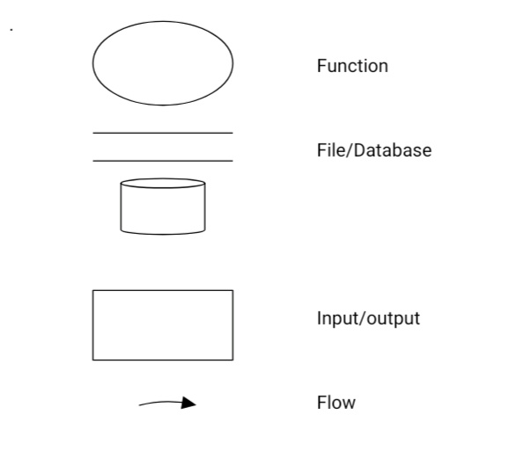

**LEVEL 0:**

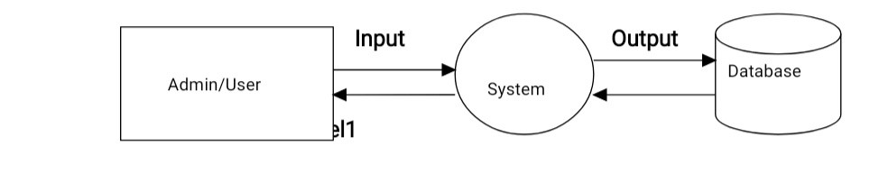

**LEVEL 1:**

**ENTITY RELATIONSHIP (E – R) DIAGRAM:**

**USER DATABASE**

**PRODUCT DATABASE**

**DATABASE FOR PROJECT**

**Home page**

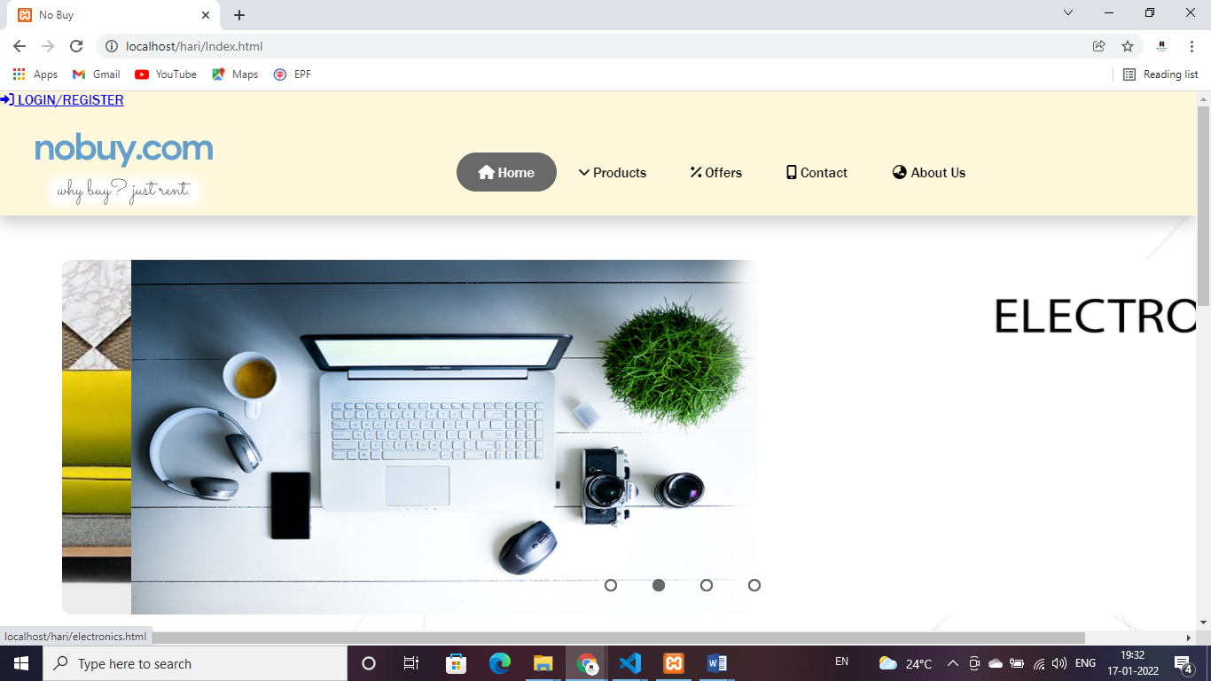

**Home page of Banner of offer**



Home page: This page consists of all the pages which is connected all in one page.

**Footer:**

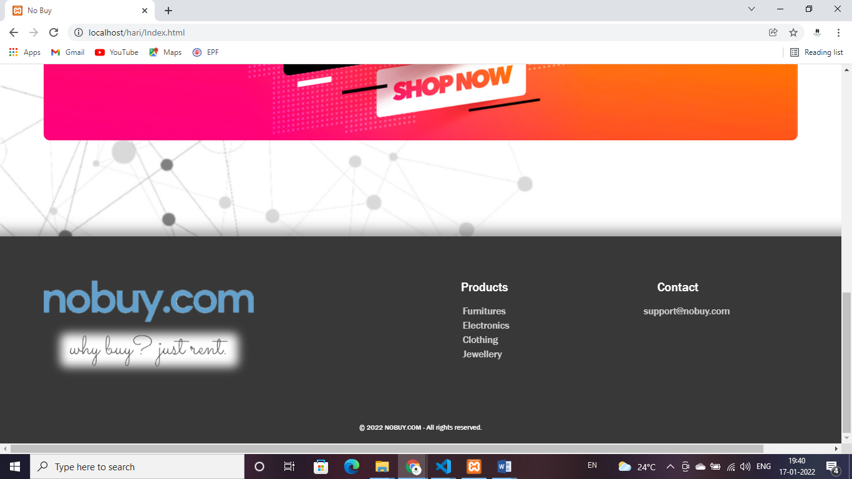

**Products page**

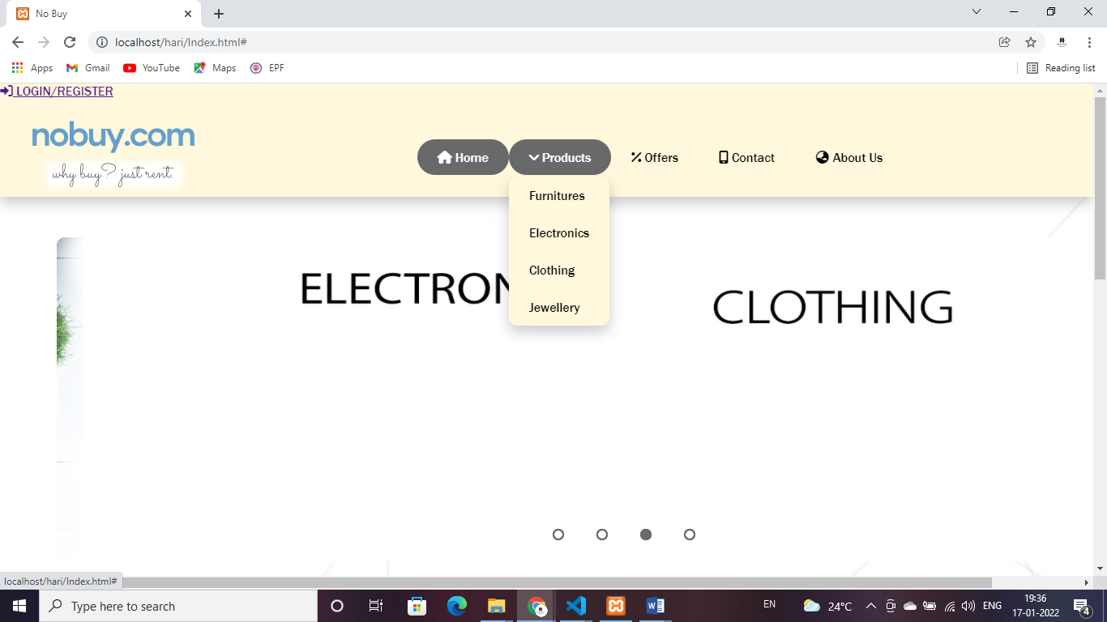

**Product page :** This gives the details of product list with dropdown method and includes the products page Furnitures ,Electronics, Clothing, Jewelleries.

**Furniture**

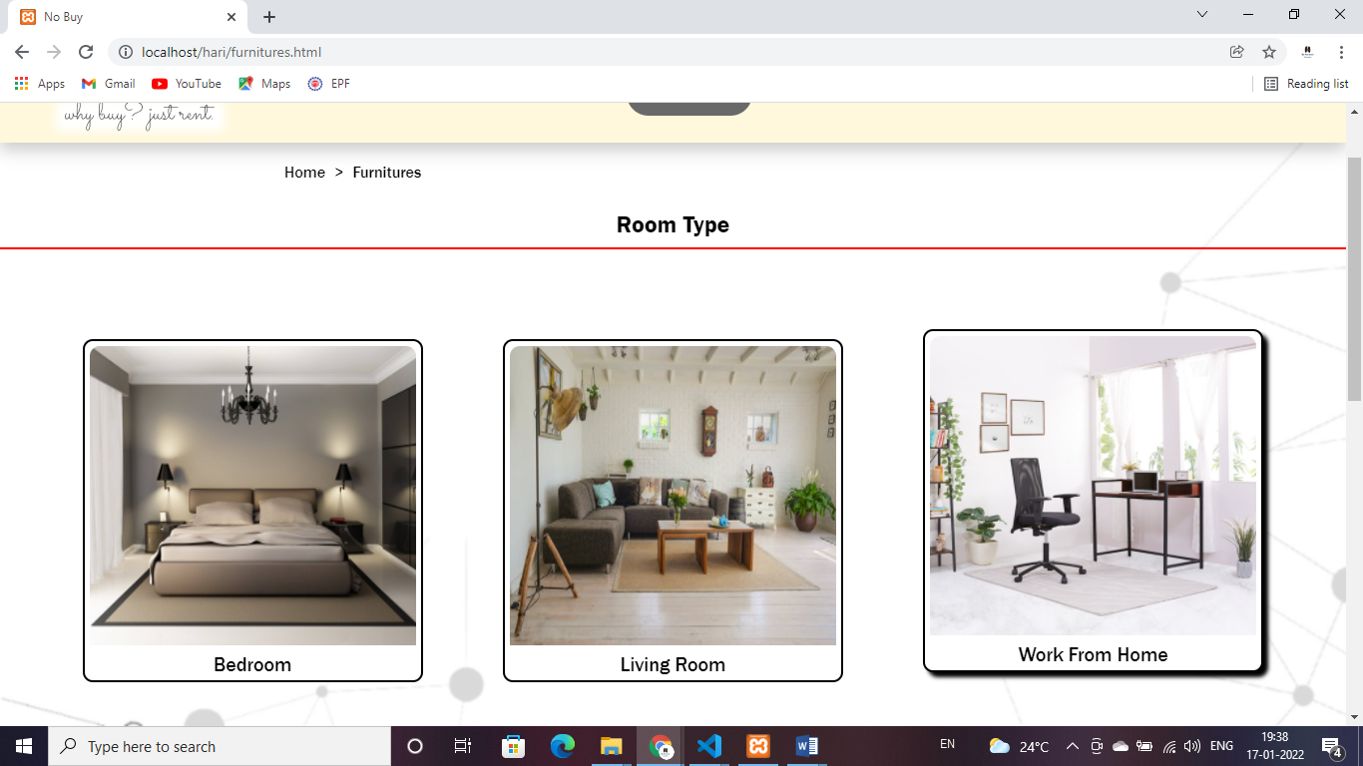

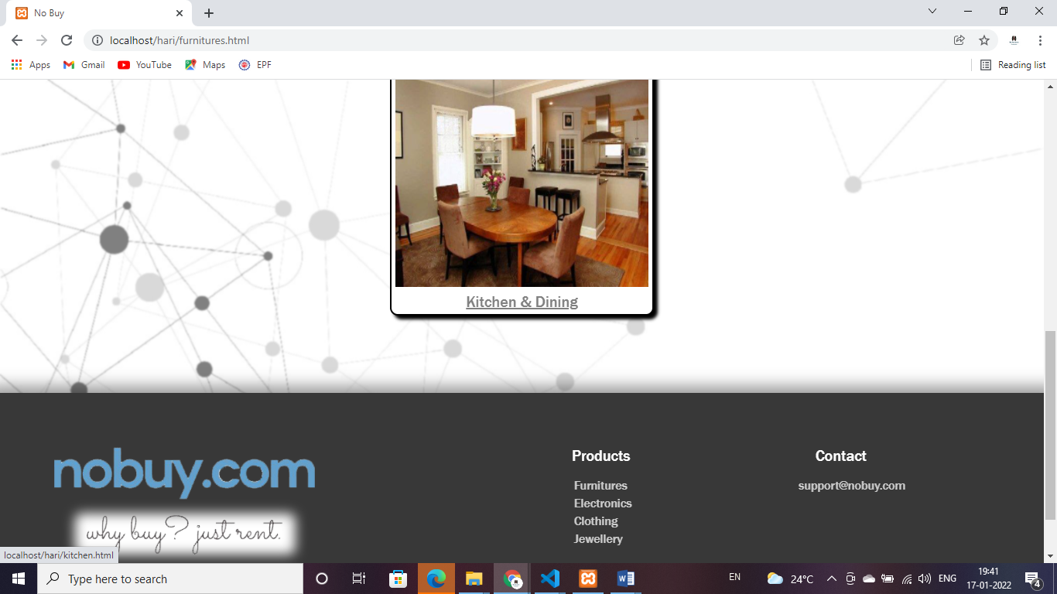

**Room type page**: This page gives details room type and product list of furniture collection for Bedroom, Living room, Work from Home & Kitchen and Dining.

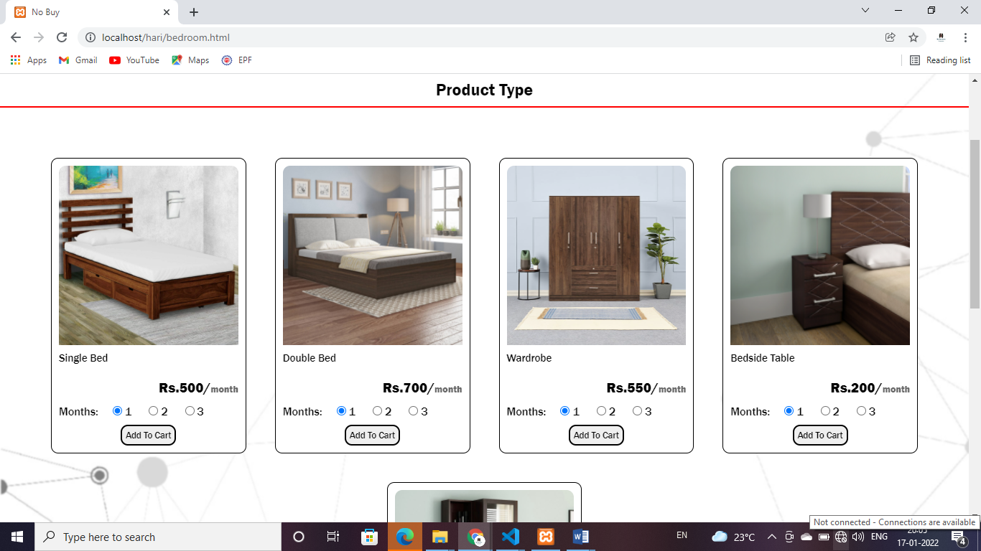

**Product type page:** This page gives details product type and product list of furniture Items for Bedroom.

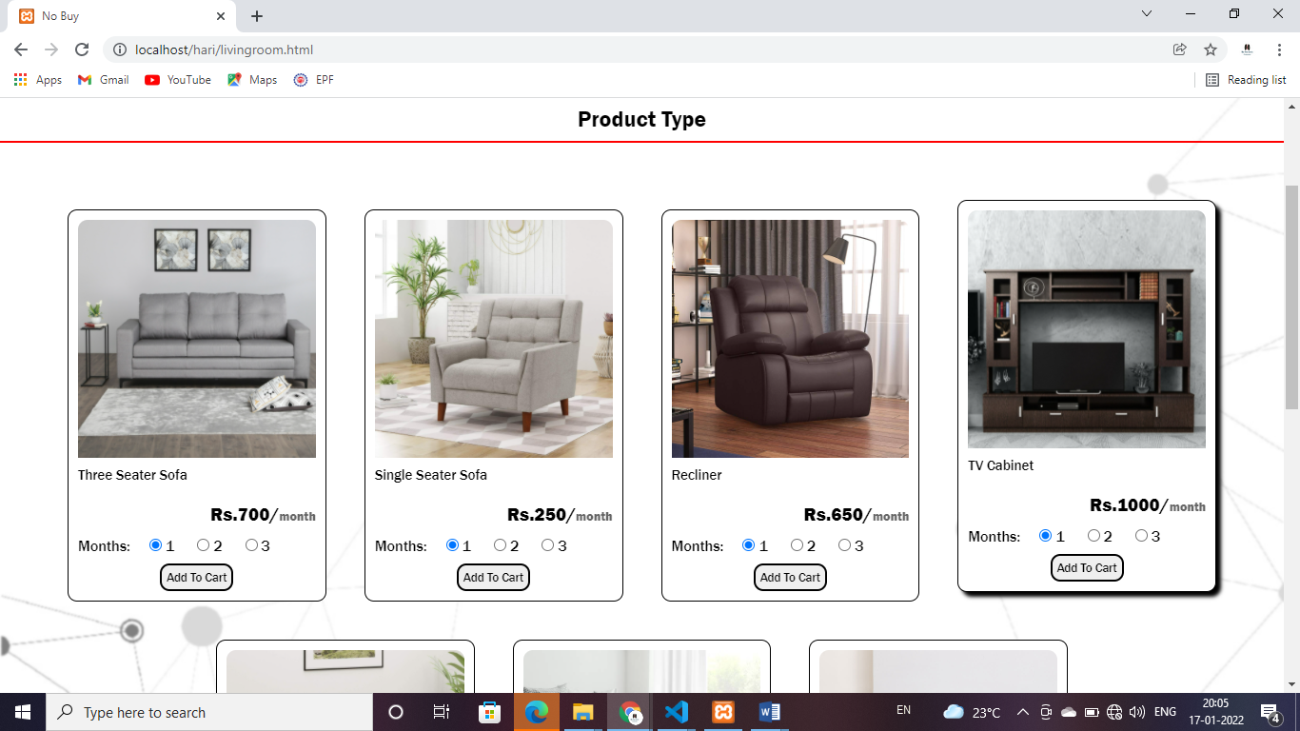

**Product type page:** This page gives details product type and product list of furniture Items for Living Room.

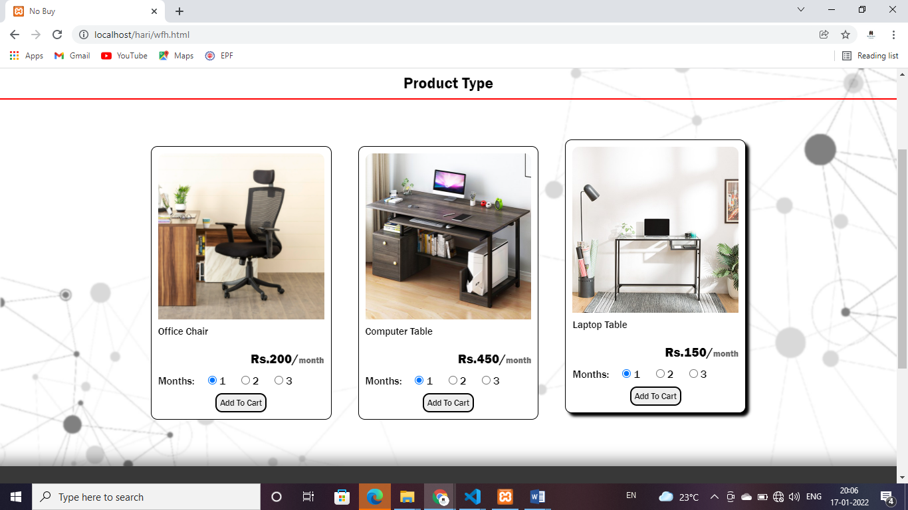

**Product type page:** This page gives details product type and product list of furniture Items for Work from Home.

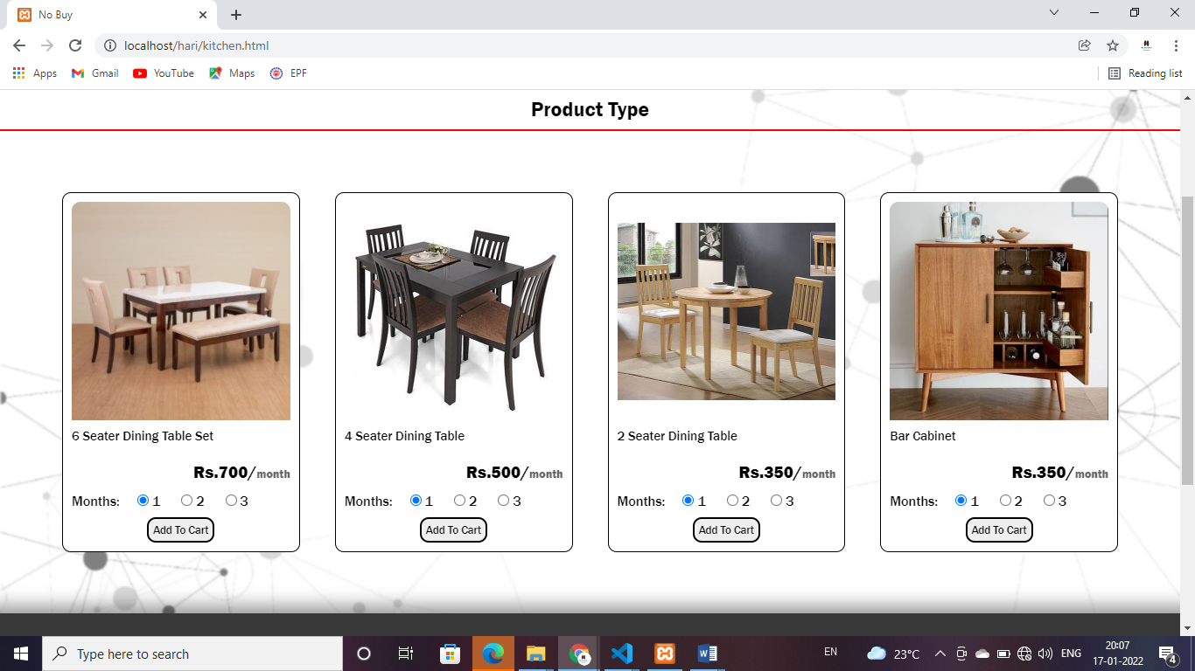

**Product type page:** This page gives details product type and product list of furniture Items for kitchen and dining.

**Electronics**

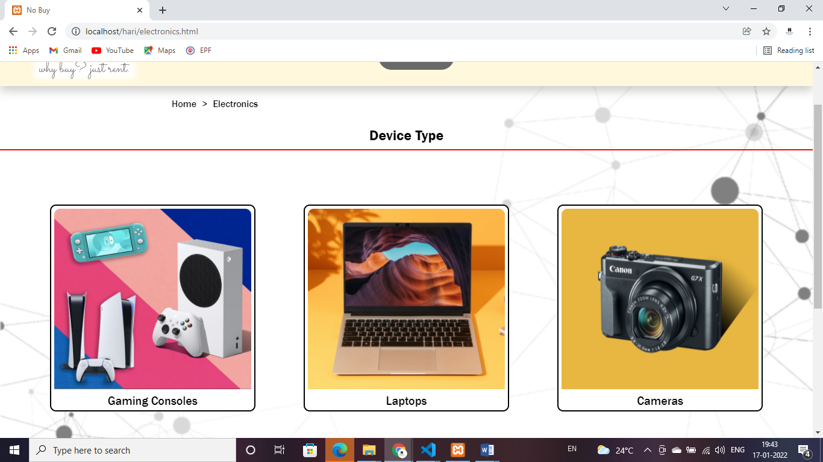

**Product type page:** This page gives details product type and product list of electronics device.

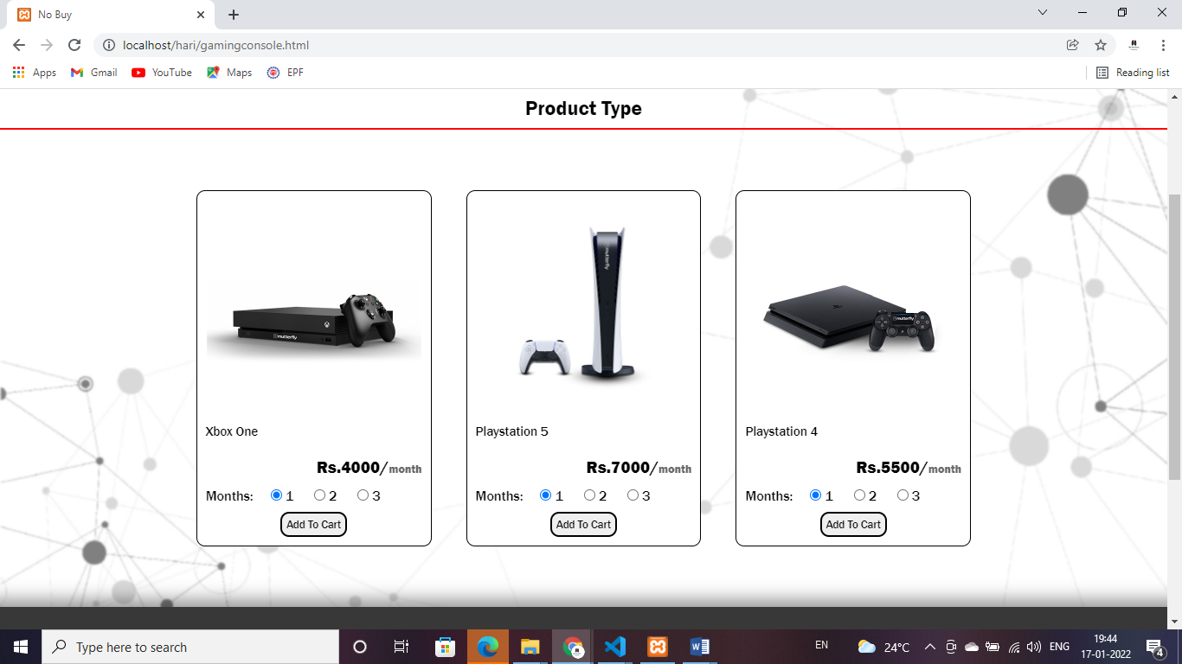

**Product type page:** This page gives details product type and product list of electronics and games consoles collection.

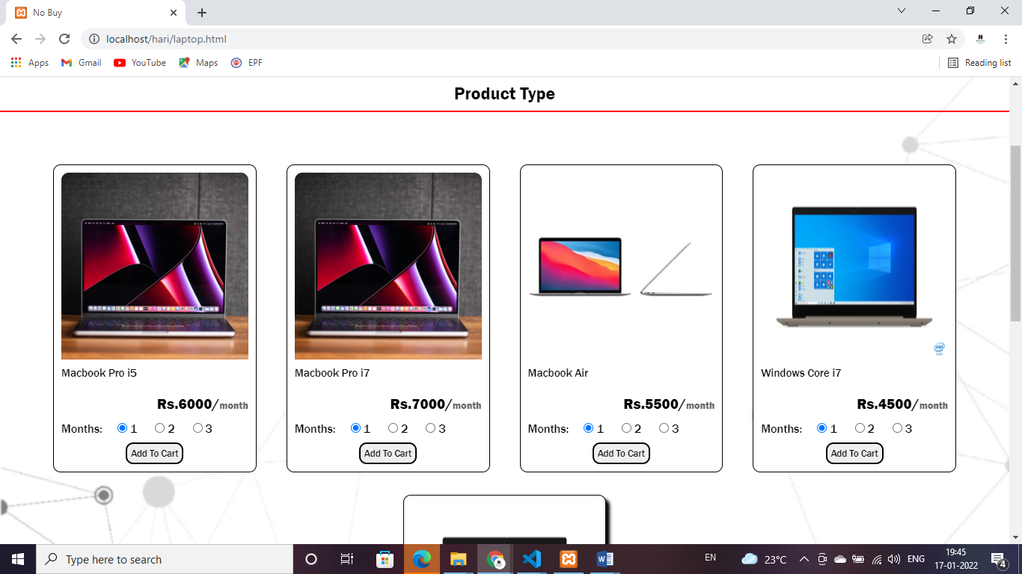

**Product type page:** This page gives details product type and product list of electronics and laptop collection.

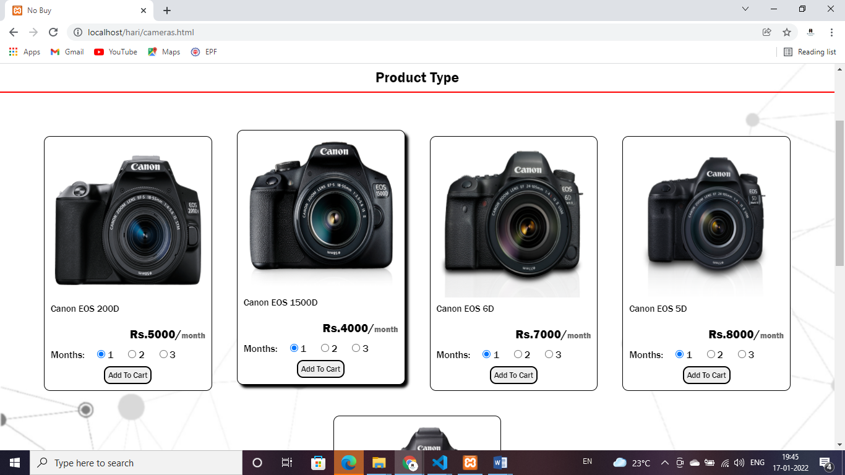

**Product type page:** This page gives details product type and product list of electronics and camera collection.

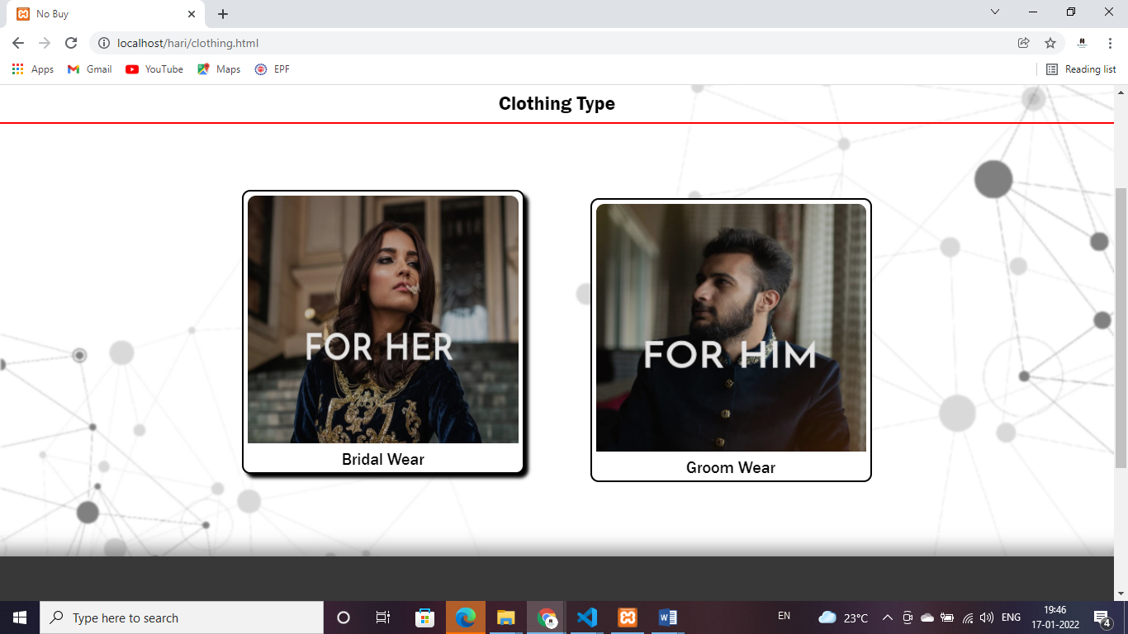

**Clothing type page:** This page gives details of the Bridal wear & Groom wear collection.

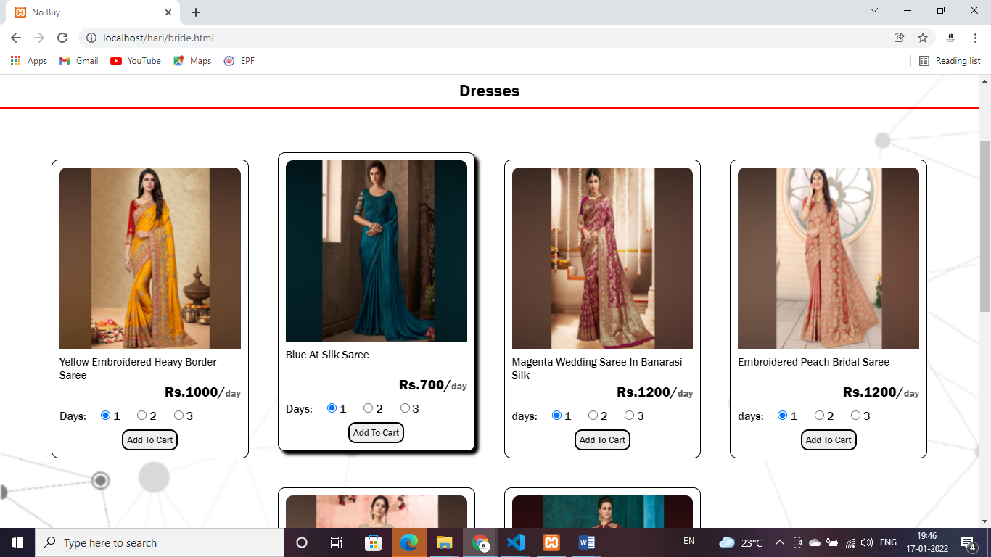

**Clothing page:** This page gives details of the women bridal dresses collection.

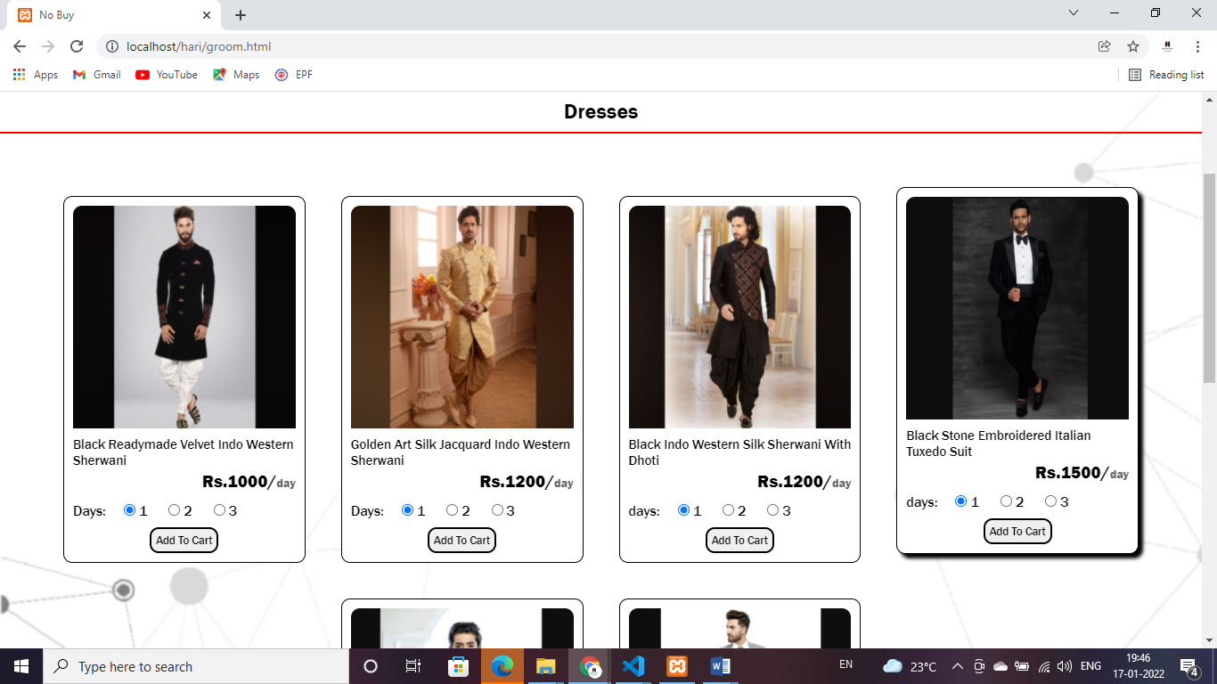

**Clothing page:** This page gives details of the men groom dresses collection.

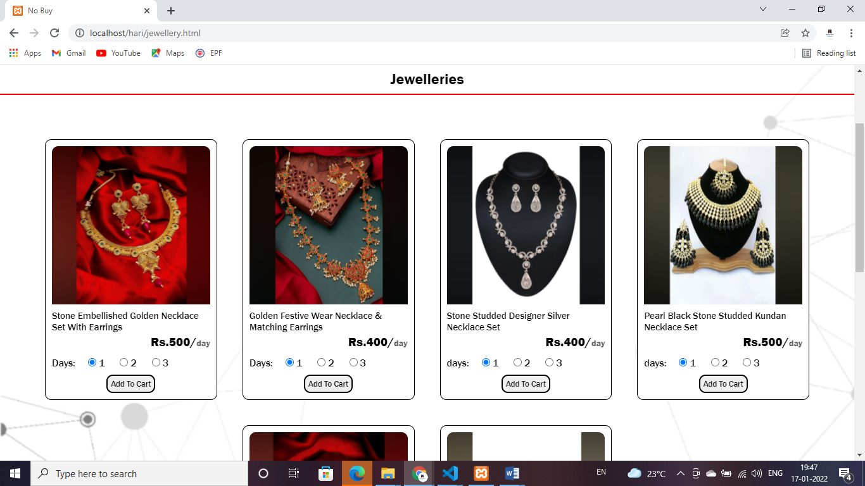

**Jewelleries page:** This page gives the details of the Jewellery Item details.

**Offer page**

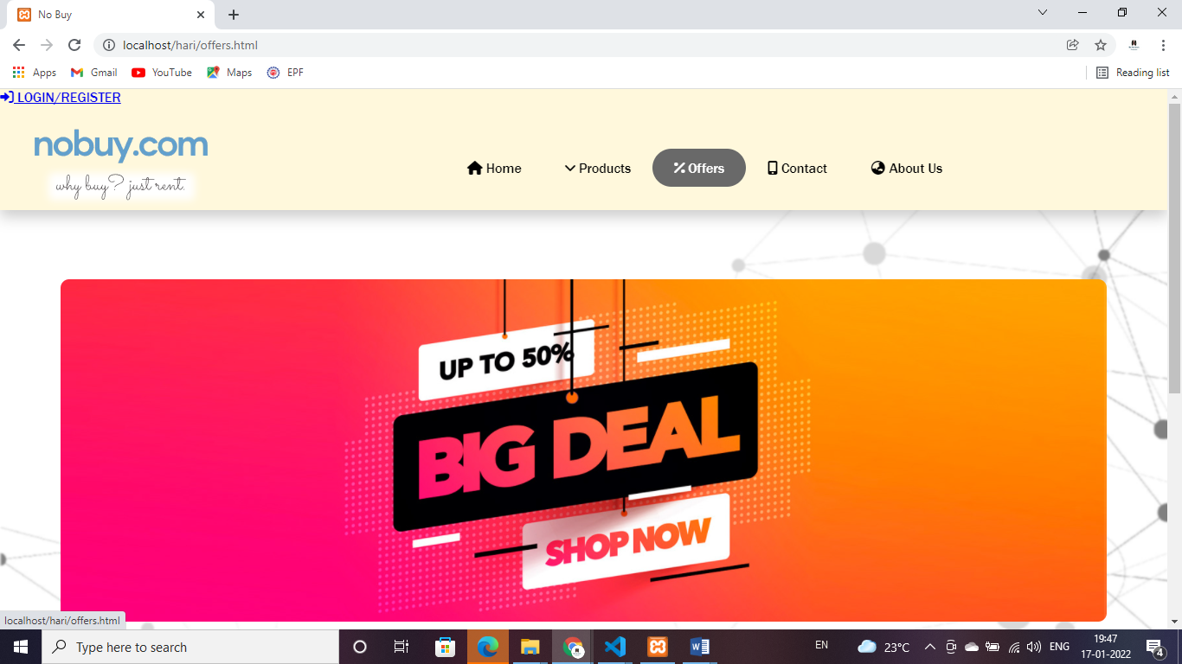

**Offer page :** This page give the details of the current offer.

**Contact US page**

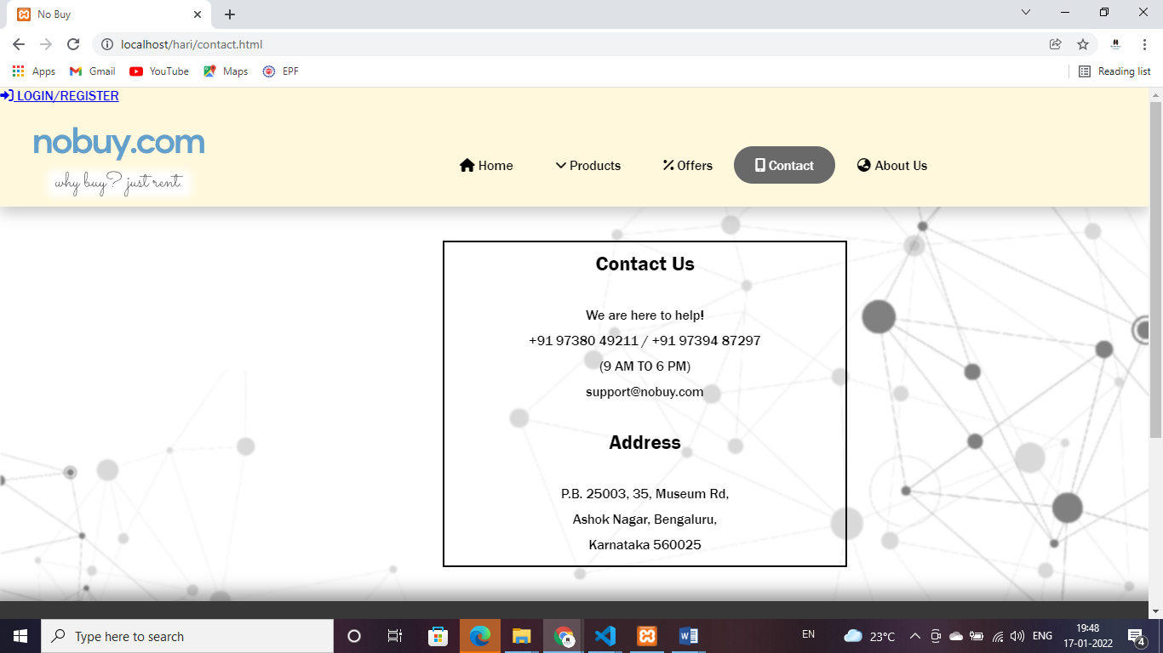

**Contact us page**: this page gives the contact details and address of the founder.

**About Us Page**

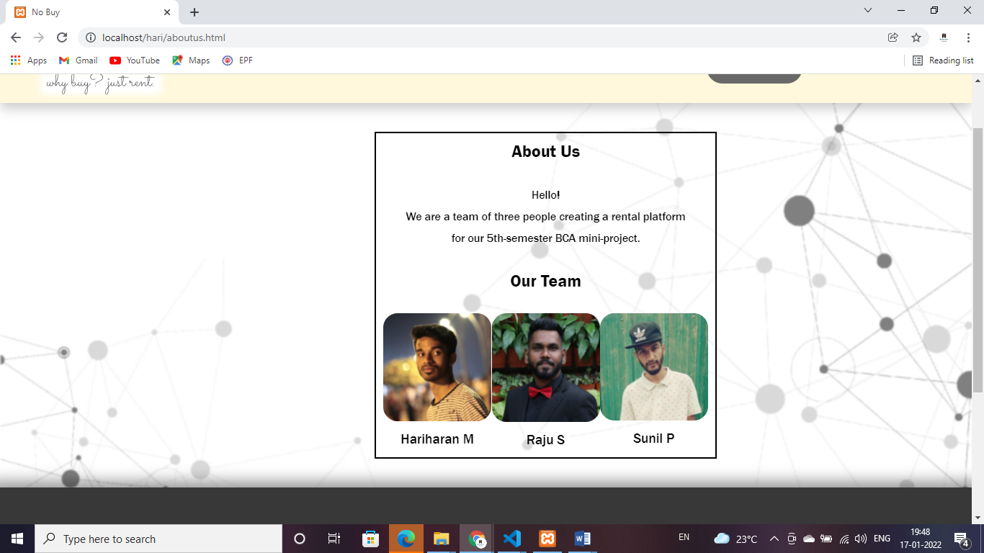

**About Us page :** This page will give the information about designer and developer of this site.

**TESTING:**

**RESULTS**:

**CONCLUSION:**

**FUTURE RECOMMENDATIONS:**

As this is just a prototype of a static website, our future plan is to develop a completely responsive dynamic website with online billing process, automated chat bot, responsive search bar, filters and few more products.

**BIBLIOGRAPHY:**

Rentomojo: https://www.rentomoj o.com

Wlend : <https://www.wlend.in>

Olx : https://www.olx.in